### Experiment – No-12

|  |  |  |
| --- | --- | --- |
| Objective: Program to display the pattern. | | |
| Scheduled Date | Compiled Date | Submission Date |
| 09-Jan-2021 | 09-Jan-2021 | 10-Jan-2021 |

### Program : A program to display the pattern.

### 

### 1

### 11

### 111

### 1111

### 11111

### Algorithm

### Step 1 - Start

### Step 2 - Input variable row,element,n

### Step 3 - Read variable of n.

### Step 4 – Apply loop.

### (row=1;row<=n;row++)

### Step 5- Apply inner loop

### (element=1;element<=row;element++)

### Step 6- Print Pattern.

**Program**

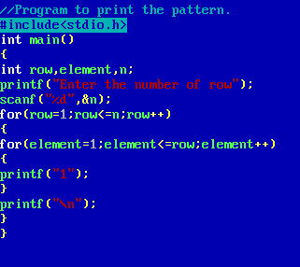

### Output Screen

### C:\Users\WIN10\Pictures\ss4.png